HTML Day 1HW Assignment

1 Design HTML Web Page as per Below image

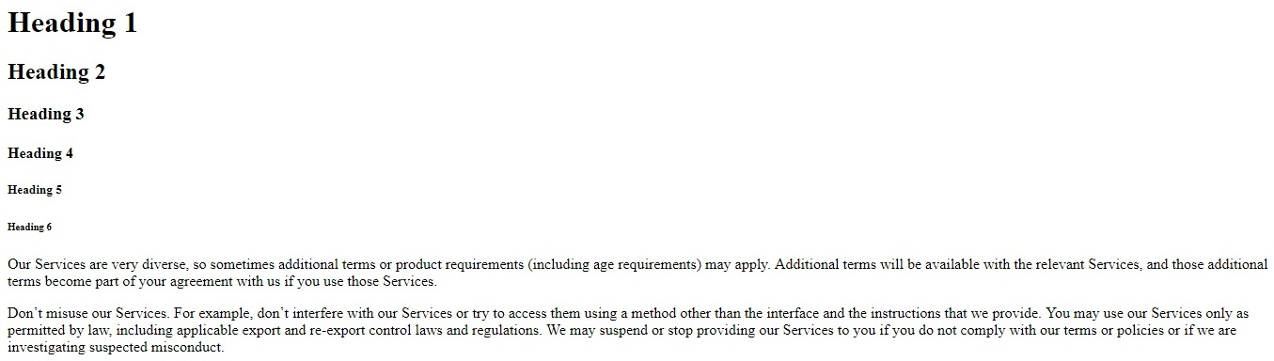

2 Display Following equation on web page

H2O,x=ax1+bx2,Ti+2= Ti+Ti+1, 24=16,x4+y6, 9th of May

3 Design HTML Web Page as per Below image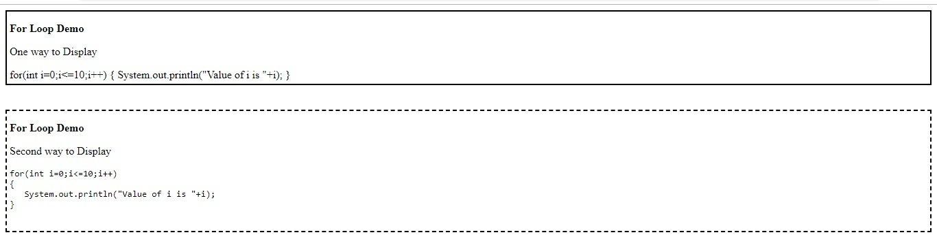

4 Design HTML Web Page as follow

abcd

dcba

hint:to display this text "dcba" use here appropriate tag

5 Display 10 images as shown below.

Row 1: Image1, Image 2, Image 3

Row 2: Image 4, Image 5, Image 6

Row 3: Image 7, Image 8, Image 9

Row 4: Image 10

Don't use <table> tag.

All images should have equal width height (For exmaple, 300px width, 200px height)

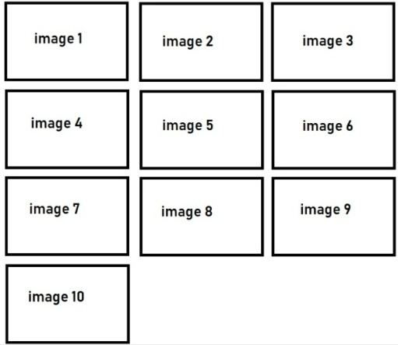

6 Design web page as below

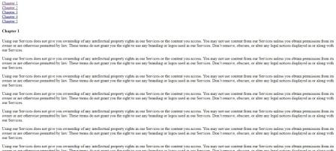

using hyperlink tag on the same page for e.g if you click on chapter 1 on same page it display chapter 1 content same Also go to top facility should be there

7 Design Tourist web page as sample below

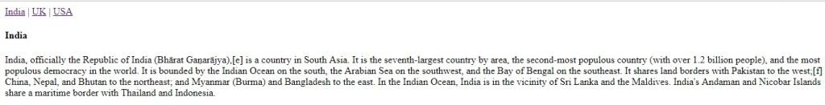 Choose countries of your choice and when user clicks on name of that country it displays the information regarding that country and each country has different pages

**8 Create web page containing information about wonders in the world when you click on image of it information about it should get displayed in browser tab**

9 **Create a list containing country name abbreviations. When move cursor on it display full form of that country. Hint: for country list out use list tag**

10 **Create nested lists containing a hierarchy of cities in states, of respective countries**

11 **Display Table as below use Appropriate HTML Tag**

|  |  |  |
| --- | --- | --- |
| **Company** | **Contact** | **Country** |
| **TCS** | **ABC** | **Germany** |
| **Infosys** | **XYZ** | **Mexico** |
| **L&T** | **SDG** | **India** |
| **Tech Mahindra** | **STR** | **India** |
| **Renuka Group** | **RSA** | **Canada** |
| **Capgemini** | **KSL** | **Italy** |

12 Design web page as per below image use appropriate tag

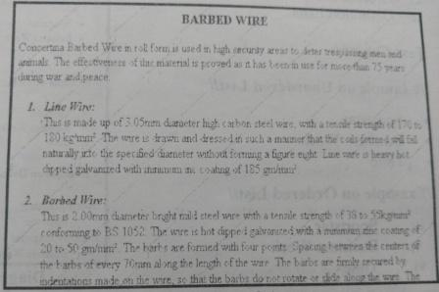

13 Display Table in below format on web page

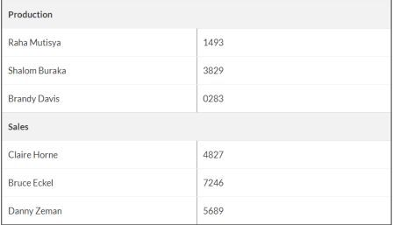

14 Display Table in below format on web page

